Ex.No.7: Use AFLogical OSE to Extract Data from an Android Device
Aim
To extract logical data such as contacts, SMS, and call logs from an Android device using AFLogical OSE and analyze the collected evidence for forensic purposes.
STEP 1 — Prepare the Required Files
Files Required
- Android Platform Tools (ADB)
- AFLogical OSE APK
- Google USB Driver for Windows
- Android device
- USB data cable
Procedure
- Create a main folder for the experiment:
C:\ForensicLab
- Create the following folders:
C:\ForensicLab\platform-tools\
C:\ForensicLab\aflogical-ose\
C:\ForensicLab\output\
- Place the downloaded files in their respective folders.
- If the AFLogical OSE APK is not available, use the appropriate AFLogical OSE source or a forensic environment such as Santoku Linux.
STEP 2 — Add Platform Tools to PATH
Purpose
To allow ADB commands to be executed directly from Command Prompt.
Procedure
- Open:
Control Panel → System → Advanced system settings → Environment Variables
- Under User Variables, select Path → Edit → New.
- Add the following platform-tools location:
C:\Users\ASUS\Downloads\platform-tools
- Click OK to save the changes.
Verification
Open a new Command Prompt and execute:
adb version
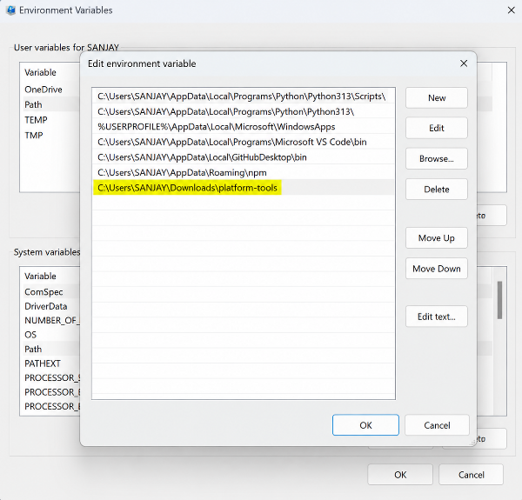
STEP 3 — Install Google USB Driver
Purpose To enable the Windows computer to communicate with the Android device through ADB. Procedure
- Connect the Android phone to the computer using a USB data cable.
- Open Device Manager.
- Locate the connected Android device.
- Right-click the device and select Update Driver.
- Select Browse my computer for drivers.
- Select the Google USB Driver folder.
- Click Next and complete the installation. Verification Open Command Prompt and execute:
adb devices
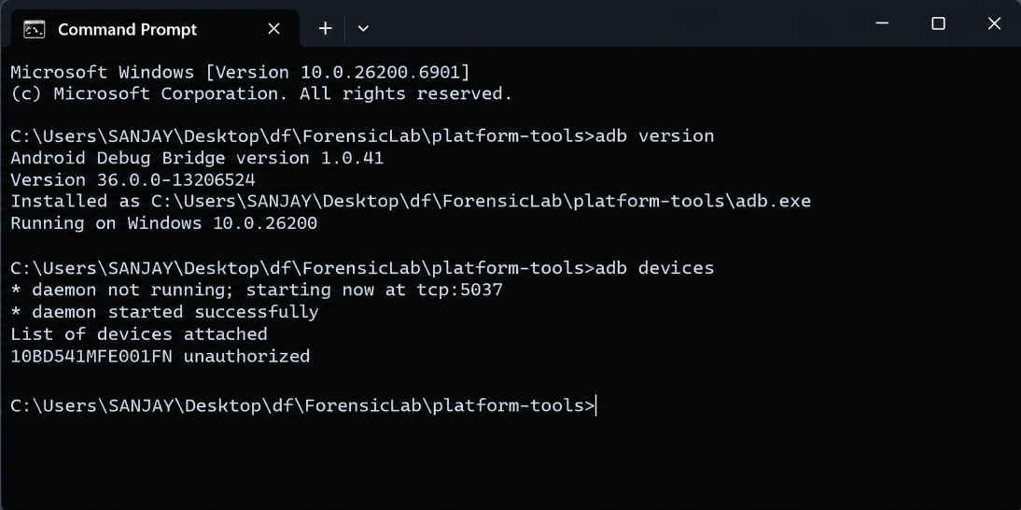
STEP 4 — Enable Developer Options on the Phone
Procedure
- Open Settings on the Android phone.
- Go to About phone.
- Tap Build number seven times.
- Return to Settings and open Developer options.
- Enable:
  - USB debugging
  - Install via USB, if available.
STEP 5 — Connect the Phone and Check ADB Connection
Purpose To verify communication between the forensic workstation and the Android device. Procedure
- Connect the phone using a USB data cable.
- Unlock the phone.
- Open Command Prompt or PowerShell.
- Execute:
adb devices
- If the phone displays an authorization request, select Allow USB debugging.
- Run the command again:
adb devices
STEP 6 — Install AFLogical OSE on the Phone
Purpose To install the forensic extraction application on the Android device. Procedure
- Ensure that the AFLogical OSE APK is available in: C:\ForensicLab\aflogical-ose\AFLogical-OSE.apk
- Open Command Prompt.
- Execute:
adb install "C:\ForensicLab\aflogical-ose\AFLogical-OSE.apk"
- Wait for the installation to complete.
- The following message indicates successful installation:
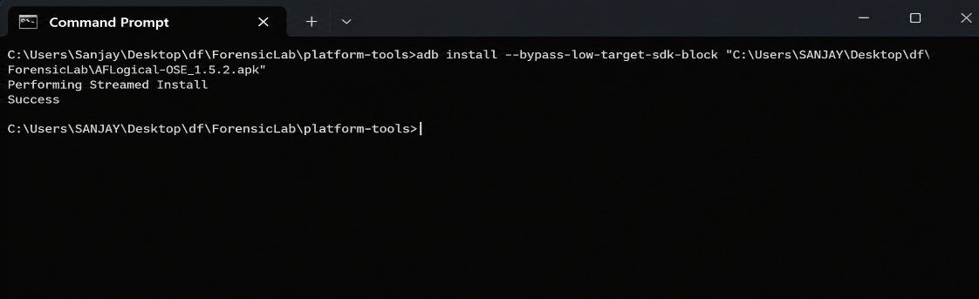
- Check the Android device and verify that AFLogical OSE is installed.
STEP 7 — Run AFLogical OSE and Extract Data
Purpose To perform logical extraction of supported data from the Android device. Procedure
- Open the AFLogical OSE application on the Android device.
- Grant the required permissions.
- Select the available data categories for extraction, such as:
  - Contacts
  - SMS
  - Call Logs
  - MMS
  - MMS Parts
- Start the extraction process.
- Wait until the extraction is completed. Verify the Extracted Data The forensic output can be checked using:
adb shell ls /sdcard/forensics
STEP 8 — Copy Extracted Data to the Computer
Purpose To transfer the extracted forensic data from the Android device to the computer for further examination. Procedure
- Create the output folder:
mkdir C:\ForensicLab\output
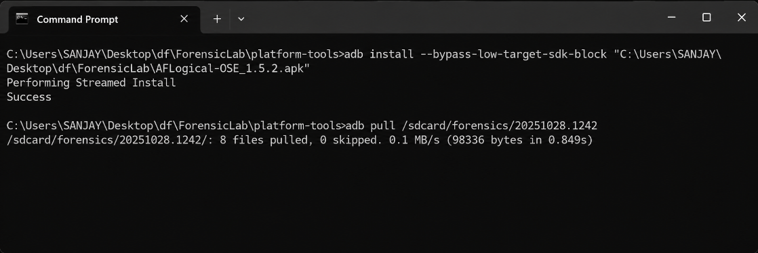
2. Copy the extracted forensic data using: ```cmd adb pull /sdcard/forensics/ "C:\ForensicLab\output" ``` 3. Wait for the transfer to complete. 4. Check the transferred files using: ```cmd dir "C:\ForensicLab\output" ``` 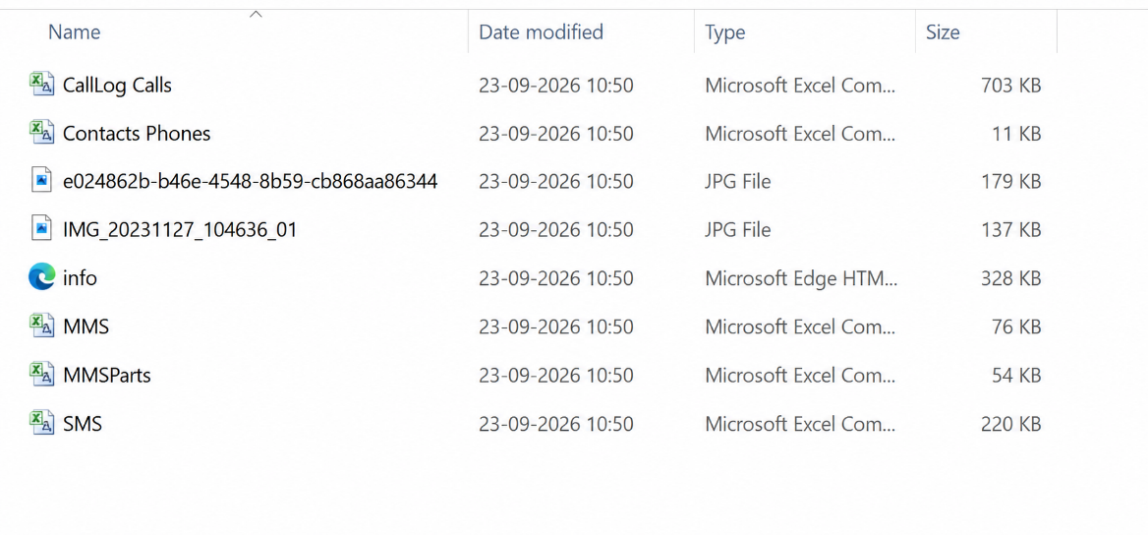
STEP 9 — Verify Integrity Using SHA-256
Purpose To verify the integrity of the extracted forensic evidence. Windows PowerShell Execute:
Get-FileHash "C:\ForensicLab\output<extracted-file>" -Algorithm SHA256
Record the generated SHA-256 hash value in the forensic report. Linux/macOS sha256sum
STEP 10 — Clean Up
After completing the extraction:
- Close the AFLogical OSE application.
- Uninstall AFLogical OSE from the Android device if required.
- Disconnect the Android device safely.
- Preserve the extracted forensic files and recorded hash values for documentation.
Result
The Android device was successfully connected to the forensic workstation using ADB. AFLogical OSE was installed and used to perform logical extraction of the supported mobile data. The extracted forensic output was transferred to the computer and examined for available contacts, SMS, call logs, MMS, and related information. SHA-256 hashing was used to verify the integrity of the selected extracted evidence.

